CE 641 Mid-Term Exam

Take-Home Part

A Unit Response of BOD/DO Model for Walnut Creek

Shibo Wang
SW5QC@VIRGINIA.EDU
October 16 2007

Parameters:
Upstream Flow Rate of the Troy Plant: 6.14 cfs
Water Temperature: 27°C
In-Stream CBOD Deoxygenation Rate: K_{d} = 0.06 day⁻¹
In-Stream CBOD Removal Rate: K_{r} =0.06 day⁻¹
In-Stream CBOD Nitrification Rate: K_{n} = 0.06 day⁻¹
Saturated Oxygen Concentration: C_{s}= 468/(31.6+27)=7.986mg/L
Requirement:
DO＞5mg/L in the receiving water

Walnut Flow:
2.85 mile
2.00 cfs
6.39 mile
1.5 cfs
7.13 mile
31.5 cfs

5.04 mile
2.40 cfs
Troy STP
1.2 mile
4.76cfs

X

0.0mile 6.14cfs
27.0°C
Walnut Creek

By neglecting the effect of other factors, contribution of each components, (i.e. CBOD load, NBOD load, DOD load from Troy plant, SOD in Walnut Creek, and combined upstream CBOD/NBOD/DOD) is quantified by following steps:
(1).Run the STREAM model, in order to, maintain DO above 5mg/L in the receive water, i.e. not beyond the assimilative capacity, the CBOD load should be 810 lb/day.
(2).Run the STREAM model, making the NBOD load, DOD load, SOD of Troy inflow and SOD of reach 3 to 6 zero, CBOD 810 lb/day.
(3).Run the STREAM model, making the CBOD load, DOD load, SOD of Troy inflow and SOD of reach 3 to 6 zero, NBOD 39.7 lb/day.
(4).Run the STREAM model, making the CBOD load, NBOD load, SOD of Troy inflow and SOD of reach 3 to 6 zero, DOD 19.2 lb/day.
(5).Run the STREAM model, making the CBOD load, NBOD load, DOD load, SOD of Troy inflow zero, SOD of reach 3 to 6 1.0 gm⁻²day⁻¹.
(6). Run the STREAM model, making the CBOD, BOD, DOD of upstream flow zero.

Unit Response Analysis:
1. DO consumption of CBOD load from the Troy plant:
According to my calculation, (DOD_{max})=0.004mg/L, CBOD load=810 lb/day
Therefore, unit response: 0.004/8.1=4.94*10⁻⁴ (mg/L DO consumption)/(100 lb/day)
2. DO consumption of NBOD load from the Troy plant:
(DOD_{max})=0mg/L, NBOD load=39.7 lb/day
Therefore, unit response: 0 (mg/L DO consumption)/(100 lb/day)
3. DO consumption of DOD load from the Troy plant:
(DOD_{max})=0.326mg/L, DOD load=19.2 lb/day
Therefore, unit response: 0.326/0.192=1.7 (mg/L DO consumption)/(100 lb/day)
4. DO consumption of SOD load in Walnut Creek:
(DOD_{max})=1.894mg/L, SOD =1.0 g O₂ m⁻²day⁻¹
Therefore, unit response: 1.894/1=1.894 (mg/L DO consumption)/( 1 g O₂ m⁻²day⁻¹)
5. DO consumption of Upstream CBOD/NBOD/DOD combined:
(DOD_{max})=2.126mg/L, Loading rate=6.14*5.4*(1.2+2.876+2.5)=218 lb/day
Therefore, unit response: 2.126/2.18=0.98 (mg/L DO consumption)/(100 lb/day)
(Input data file of each condition is in the appendix.)

(a) Plot accumulated DO consumption vs. Distance:
According to the results gained from running STREAM model under different conditions, net DO consumption by CBOD, NBOD, DOD load from Troy plant, SOD in Walnut Creek and combined upstream CBOD/NBOD/DOD is acquired respectively. Plot these result in the same diagram and add them together to see the accumulation effect of DO consumption, which varies with distance. The result is shown below:

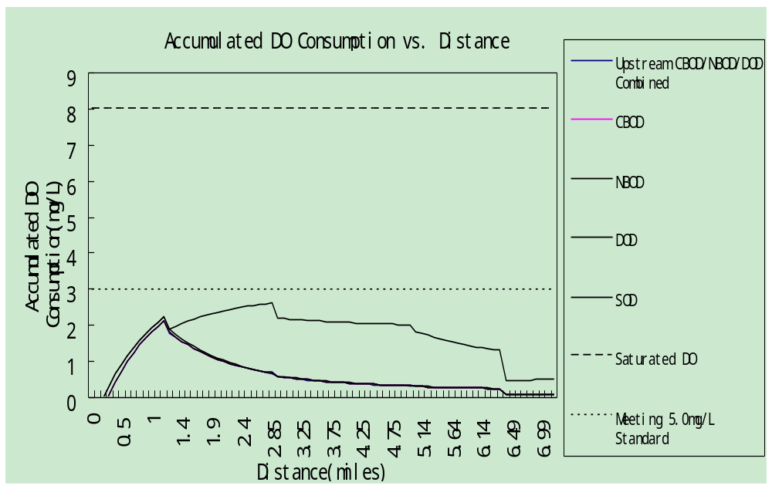
saturated DO
Meeting 5.0 mg/L DO Standard
SOD
Upstream Combined

In the plot above, the dash line shows the saturated DO concentration of 7.986 mg/L under 27°C , and the solid lines respectively indicate combined upstream CBOD/NBOD/DOD, the DO consumption due to CBOD load, NBOD load, DOD load from the Troy wastewater treatment plant, and SOD in Walnut Creek from the bottom to the top. Region between the CBOD line and X axis represents the DO consumption cost solely by upstream CBOD/NBOD/DOD. Region between CBOD and Upstream lines shows the net DO consumption share caused by CBOD in Troy STP. It should be noticed that, since no nitrification in the Walnut Creek, NBOD load from Troy plant doesn’t contribute to the total DO consumption. Therefore, in the plot, the CBOD line and NBOD line are superposed. Region between NBOD/CBOD and DOD lines reflects the tiny significance done by DOD from Troy plant to the total DO consumption. Region between DOD and SOD lines clearly indicates that because of the effect of settling, i.e. SOD in Walnut Creek, DO is consumed significantly. This result demonstrates that SOD plays the most significant role on consuming dissolved oxygen in Walnut Creek. Within the context of the top solid line, the accumulated DO consumption can be found easily for every spots along the distance. Region between SOD and 5.0 mg/L standard lines is actually the practical capacity of Walnut Creek to assimilate BOD and SOD, i.e. DO budget. According to this, extra load can be disposed into the creek.
(b) Additional CBOD load for Troy plant:
With the water quality requirement that DO should be above 5 mg/L, each spot along the river can consume DO as much as 2.986 mg/L (7.986-5.0)(i.e. the dash-spot line in the plot around 3 mg/L). Due to the dredged river bottom, SOD in Walnut Creek, which indicates the sediment DO consumption becomes zero. Therefore, additional CBOD load from Troy plant is allowable. According to the plot above, it can be found that the maximum DO consumption due to SOD happens at 2.85 miles, SOD_{max}=1.92mg/L.
Therefore, the additional CBOD load from Troy plant should be:
1.92mg/L * 4.76cfs * 5.4=49.4lb/day

APPENDIX:
Input data file:
1.
0 1
Wasteload Allocation Model for Walnut Creek, Alabama October 1991 Hydraulic Geometry
6.0 -0.2 0.10 1.00
1.20 0.0 2.876 0.0 2.50 0.0 0.0 0.0 0.001
6.14 0.5 35.9 27.0 0.0 0.0 0.0 0.0
0.0 810.0 0.0 39.7 0.0 19.2 1.0 0.0 10.83
4.76 0.50 65.3 27.0 1.2 0.06 0.06 0.0
1.2 0.0 1.3 0.0 2.0 0.0 1.0 0.0 9.70
2.00 0.75 82.5 27.0 2.85 0.06 0.06 0.0
1.2 44.4 2.00 66.6 2.0 9.1 1.0 0.0 7.30
2.40 1.00 67.4 27.0 5.04 0.06 0.06 0.0
1.2 0.0 2.00 0.0 2.0 0.0 1.0 0.0 8.15
1.5 2.0 78.9 27.0 6.39 0.06 0.06 0.0
1.26 0.0 1.67 0.0 2.11 0.0 1.0 0.0 4.05
31.5 4.50 120.0 27.0 7.13 0.06 0.06 0.0

2.
0 1
Wasteload Allocation Model for Walnut Creek, Alabama October 1991 Hydraulic Geometry
6.0 -0.2 0.10 1.00
1.20 0.0 2.876 0.0 2.50 0.0 0.0 0.0 0.001
6.14 0.5 35.9 27.0 0.0 0.0 0.0 0.0
0.0 810.0 0.0 0.0 0.0 0.0 0.0 0.0 10.83
4.76 0.50 65.3 27.0 1.2 0.06 0.06 0.0
1.2 0.0 1.3 0.0 2.0 0.0 0.0 0.0 9.70
2.00 0.75 82.5 27.0 2.85 0.06 0.06 0.0
1.2 44.4 2.00 66.6 2.0 9.1 0.0 0.0 7.30
2.40 1.00 67.4 27.0 5.04 0.06 0.06 0.0
1.2 0.0 2.00 0.0 2.0 0.0 0.0 0.0 8.15
1.5 2.0 78.9 27.0 6.39 0.06 0.06 0.0
1.26 0.0 1.67 0.0 2.11 0.0 0.0 0.0 4.05
31.5 4.50 120.0 27.0 7.13 0.06 0.06 0.0

3.
0 1
Wasteload Allocation Model for Walnut Creek, Alabama October 1991 Hydraulic Geometry
6.0 -0.2 0.10 1.00
1.20 0.0 2.876 0.0 2.50 0.0 0.0 0.0 0.001
6.14 0.5 35.9 27.0 0.0 0.0 0.0 0.0
0.0 0.0 0.0 39.7 0.0 0.0 0.0 0.0 10.83
4.76 0.50 65.3 27.0 1.2 0.06 0.06 0.0
1.2 0.0 1.3 0.0 2.0 0.0 0.0 0.0 9.70
2.00 0.75 82.5 27.0 2.85 0.06 0.06 0.0
1.2 44.4 2.00 66.6 2.0 9.1 0.0 0.0 7.30
2.40 1.00 67.4 27.0 5.04 0.06 0.06 0.0
1.2 0.0 2.00 0.0 2.0 0.0 0.0 0.0 8.15
1.5 2.0 78.9 27.0 6.39 0.06 0.06 0.0
1.26 0.0 1.67 0.0 2.11 0.0 0.0 0.0 4.05
31.5 4.50 120.0 27.0 7.13 0.06 0.06 0.0
4.
0 1
Wasteload Allocation Model for Walnut Creek, Alabama October 1991 Hydraulic Geometry
6.0 -0.2 0.10 1.00
1.20 0.0 2.876 0.0 2.50 0.0 0.0 0.0 0.001
6.14 0.5 35.9 27.0 0.0 0.0 0.0 0.0
0.0 0.0 0.0 0.0 0.0 19.2 0.0 0.0 10.83
4.76 0.50 65.3 27.0 1.2 0.06 0.06 0.0
1.2 0.0 1.3 0.0 2.0 0.0 0.0 0.0 9.70
2.00 0.75 82.5 27.0 2.85 0.06 0.06 0.0
1.2 44.4 2.00 66.6 2.0 9.1 0.0 0.0 7.30
2.40 1.00 67.4 27.0 5.04 0.06 0.06 0.0
1.2 0.0 2.00 0.0 2.0 0.0 0.0 0.0 8.15
1.5 2.0 78.9 27.0 6.39 0.06 0.06 0.0
1.26 0.0 1.67 0.0 2.11 0.0 0.0 0.0 4.05
31.5 4.50 120.0 27.0 7.13 0.06 0.06 0.0
5.
0 1
Wasteload Allocation Model for Walnut Creek, Alabama October 1991 Hydraulic Geometry
6.0 -0.2 0.10 1.00
1.20 0.0 2.876 0.0 2.50 0.0 0.0 0.0 0.001
6.14 0.5 35.9 27.0 0.0 0.0 0.0 0.0
0.0 0.0 0.0 0.0 0.0 0.0 0.0 0.0 10.83
4.76 0.50 65.3 27.0 1.2 0.06 0.06 0.0
1.2 0.0 1.3 0.0 2.0 0.0 1.0 0.0 9.70
2.00 0.75 82.5 27.0 2.85 0.06 0.06 0.0
1.2 44.4 2.00 66.6 2.0 9.1 1.0 0.0 7.30
2.40 1.00 67.4 27.0 5.04 0.06 0.06 0.0
1.2 0.0 2.00 0.0 2.0 0.0 1.0 0.0 8.15
1.5 2.0 78.9 27.0 6.39 0.06 0.06 0.0
1.26 0.0 1.67 0.0 2.11 0.0 1.0 0.0 4.05
31.5 4.50 120.0 27.0 7.13 0.06 0.06 0.0
6.
0 1
Wasteload Allocation Model for Walnut Creek, Alabama October 1991 Hydraulic Geometry
6.0 -0.2 0.10 1.00
1.20 0.0 2.876 0.0 2.50 0.0 0.0 0.0 0.001
6.14 0.5 35.9 27.0 0.0 0.0 0.0 0.0
0.0 0.0 0.0 0.0 0.0 0.0 0.0 0.0 10.83
4.76 0.50 65.3 27.0 1.2 0.06 0.06 0.0
1.2 0.0 1.3 0.0 2.0 0.0 0.0 0.0 9.70
2.00 0.75 82.5 27.0 2.85 0.06 0.06 0.0
1.2 44.4 2.00 66.6 2.0 9.1 0.0 0.0 7.30
2.40 1.00 67.4 27.0 5.04 0.06 0.06 0.0
1.2 0.0 2.00 0.0 2.0 0.0 0.0 0.0 8.15
1.5 2.0 78.9 27.0 6.39 0.06 0.06 0.0
1.26 0.0 1.67 0.0 2.11 0.0 0.0 0.0 4.05
31.5 4.50 120.0 27.0 7.13 0.06 0.06 0.0
7.
0 1
Wasteload Allocation Model for Walnut Creek, Alabama October 1991 Hydraulic Geometry
6.0 -0.2 0.10 1.00
0.00 0.0 0.00 0.0 0.00 0.0 0.0 0.0 0.001
6.14 0.5 35.9 27.0 0.0 0.0 0.0 0.0
0.0 810.0 0.0 39.7 0.00 19.2 1.0 0.0 10.83
4.76 0.50 65.3 27.0 1.2 0.06 0.06 0.0
1.2 0.0 1.3 0.0 2.0 0.0 0.0 0.0 9.70
2.00 0.75 82.5 27.0 2.85 0.06 0.06 0.0
1.2 44.4 2.00 66.6 2.0 9.1 0.0 0.0 7.30
2.40 1.00 67.4 27.0 5.04 0.06 0.06 0.0
1.2 0.0 2.00 0.0 2.0 0.0 0.0 0.0 8.15
1.5 2.0 78.9 27.0 6.39 0.06 0.06 0.0
1.26 0.0 1.67 0.0 2.11 0.0 0.0 0.0 4.05
31.5 4.50 120.0 27.0 7.13 0.06 0.06 0.0
Pledge:
The work is all done by Shibo Wang, without any cooperation.

